User Acceptance Testing (UAT) Template
Date | 02 October 2026
Team ID | SWTID-2026-7810
Project Name | AUTO-TICKET CLASSIFICATION USING FLOW DESIGNER
Maximum Marks | —

Project Overview:
Project Name: AUTO-TICKET CLASSIFICATION USING FLOW DESIGNER
Project Description: A ServiceNow Flow Designer solution that automatically classifies school IT support tickets by evaluating keywords in the Short Description and assigning the appropriate Category and Subcategory.
Project Version: 1.0
Testing Period: 02 October 2026 to 02 October 2026
Testing Scope:
Features and Functionalities: Ticket creation; keyword-based classification; automatic Category/Subcategory assignment; Flow Designer execution; validation of ticket data; basic access/security validation.
Requirements: Users enter Caller Name and Short Description only; WiFi maps to Network/WiFi; Projector maps to Hardware/Projector; Password or Login maps to Access/Forgot Password; Slow or Hanging maps to Performance/Slow Computer.
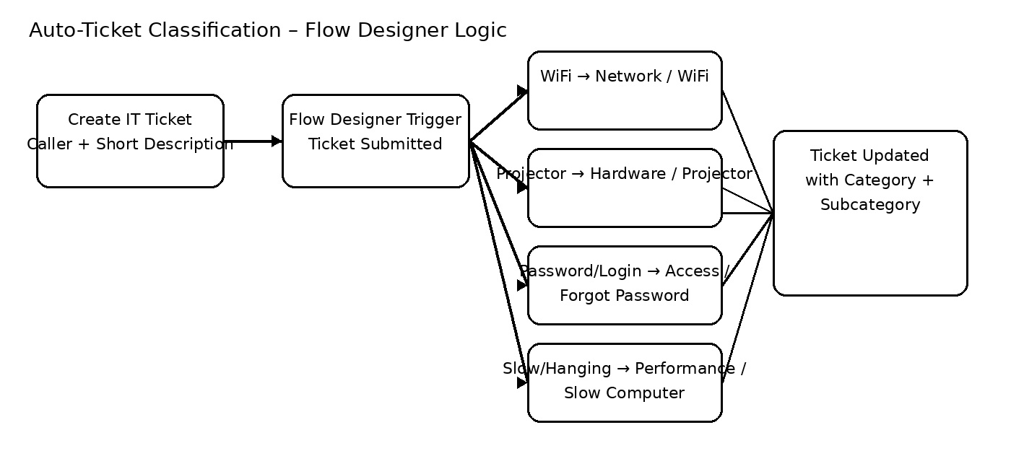
Figure 1: Illustrative Flow Designer classification path used for UAT.
Testing Environment:
Reference link: ServiceNow Flow Designer documentation
URL/Location: ServiceNow project environment / Flow Designer. Reference: ServiceNow Flow Designer documentation.
Credentials (if required): Project environment credentials to be provided by the authorized tester.
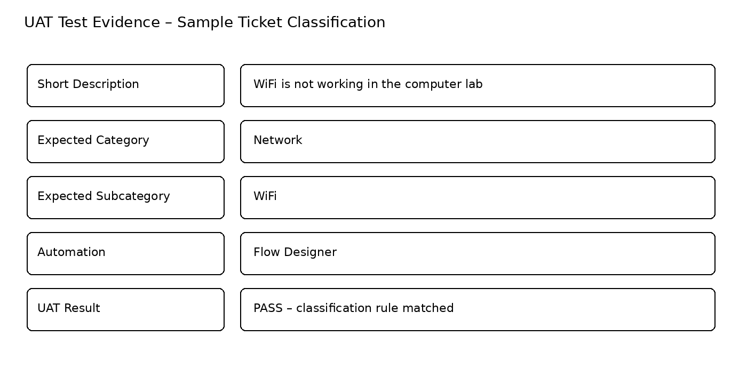
Test Case ID | Test Scenario | Test Steps | Expected Result | Actual Result | Pass/Fail
TC-001 | Positive – WiFi keyword classification | 1. Create a ticket.  2. Enter Caller Name.  3. Enter “WiFi is not working”.  4. Submit the ticket. | Category = Network and Subcategory = WiFi. | Ticket classification should be verified in the project environment. | PASS / FAIL
TC-002 | Positive – Projector keyword classification | 1. Create a ticket.  2. Enter Caller Name.  3. Enter “Projector is not working”.  4. Submit the ticket. | Category = Hardware and Subcategory = Projector. | Ticket classification should be verified in the project environment. | PASS / FAIL
TC-003 | Positive – Password/Login classification | 1. Create a ticket.  2. Enter Caller Name.  3. Enter “Forgot Password / Login issue”.  4. Submit the ticket. | Category = Access and Subcategory = Forgot Password. | Ticket classification should be verified in the project environment. | PASS / FAIL
TC-004 | Positive – Slow/Hanging classification | 1. Create a ticket.  2. Enter Caller Name.  3. Enter “Computer is Slow/Hanging”.  4. Submit the ticket. | Category = Performance and Subcategory = Slow Computer. | Ticket classification should be verified in the project environment. | PASS / FAIL
TC-005 | Negative – Unrecognized keyword | 1. Create a ticket.  2. Enter Caller Name.  3. Enter a description without the predefined keywords.  4. Submit the ticket. | No incorrect predefined classification should be assigned; behavior should be reviewed against project configuration. | Record the actual behavior observed during UAT. | PASS / FAIL
Figure 2: Illustrative UAT evidence for automatic ticket classification.
Test Cases:
Bug Tracking:
Bug ID | Bug Description | Steps to reproduce | Severity | Status | Additional feedback
BG-001 | No defect recorded at document preparation time; update during UAT if an issue is found. | If a defect occurs: reproduce the failed test case and record the exact input and flow behavior. | To be assigned | Open / Closed | Use this row to record tester feedback, severity and resolution.

Sign-off:
Tester Name:
Date: 02 October 2026
Notes:
- Ensure that all test cases cover both positive and negative scenarios.
- Encourage testers to provide detailed feedback, including any suggestions for improvement.
- Bug tracking should include details such as severity, status, and steps to reproduce.
- Obtain sign-off from both the project manager and product owner before proceeding with deployment.

